Voltech Solar Controller SCP030 & SCP050
Instructions to install the ‘Eco Solar OTA app’
This new app has been provided to make updating the operating firmware an easy 8 step process,
and can also be used for any future updates as maybe necessary from time to time.

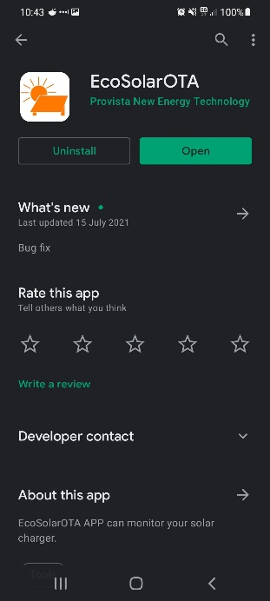
1) Download the Eco Solar OTA app from apple store / Google play store
Google play - https://play.google.com/store/apps/details?id=com.provista.solarota
Apple - https://apps.apple.com/au/app/eco-solar-ota/id1575699481

2a) The solar controller must be powered on showing home screen with Wi-fi setting turned on, the Wi-Fi symbol will be flashing if turned on, please refer to owner’s manual.

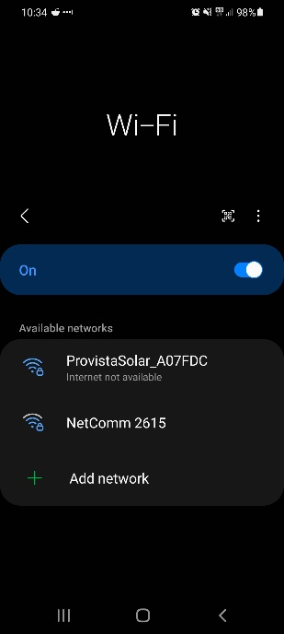
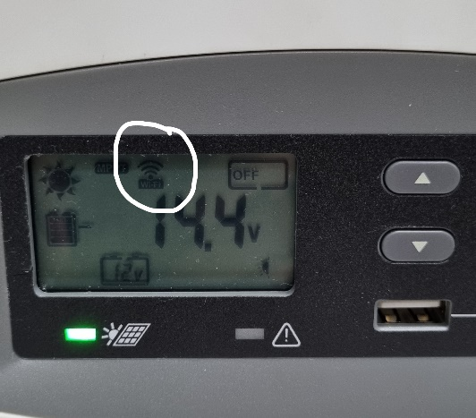

2b) Connect your device to the Voltech Solar controller.
(If a connection to the Solar controller has previously been established, simply connect your device to the solar controller as normal).

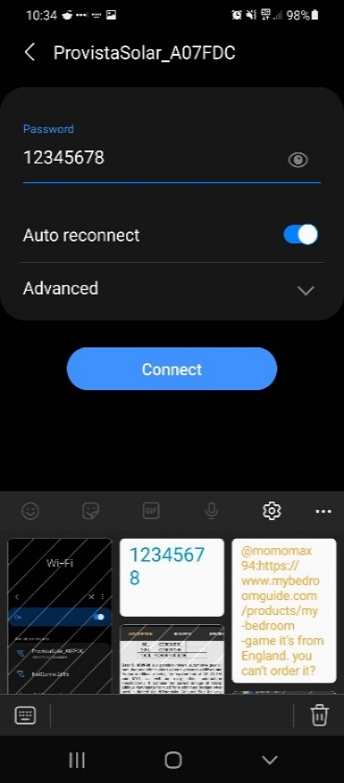
- WIFI and Bluetooth functions on your Smart phone must both be turned on for a connection to work.

- Enter the Password as shown (Default = 12345678).

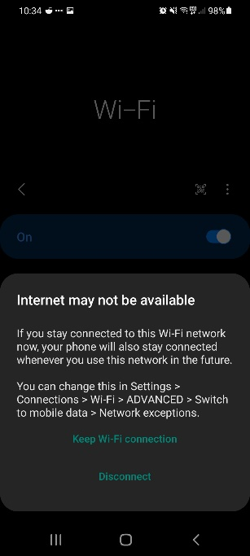
- A message may appear detailing no internet connection available, please select
“keep Wi-fi connection”

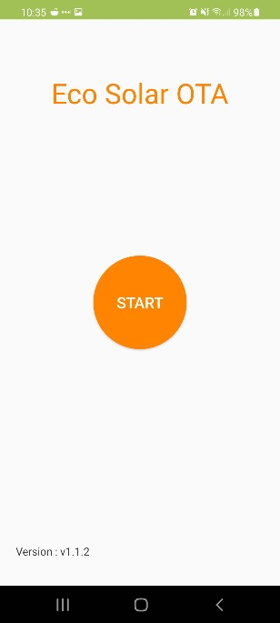
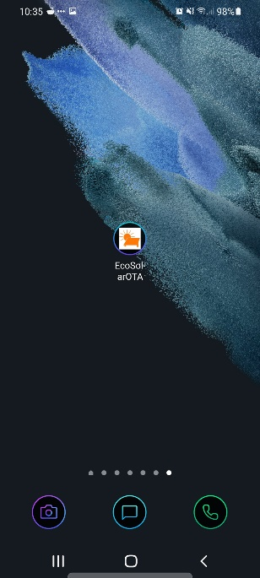

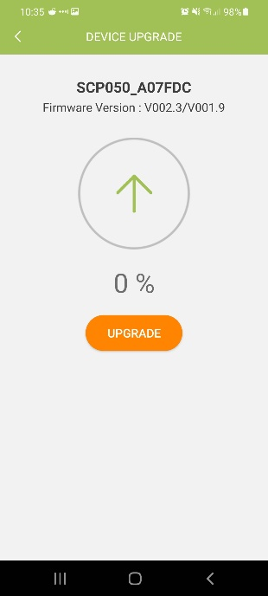
- Launch the new Eco Solar OTA app that was installed in step
1.

- Press “start”, new page will be shown, please confirm the
following is correct before proceeding:
- Correct unit is selected IE SCP050
- Correct mac address is selected IE A07FDC (this can be
confirmed by checking the mac address located on the top
right side of unit)
Please take note of current version IE V00.23/V001.9
failure to confirm above may result in incorrect unit updating.

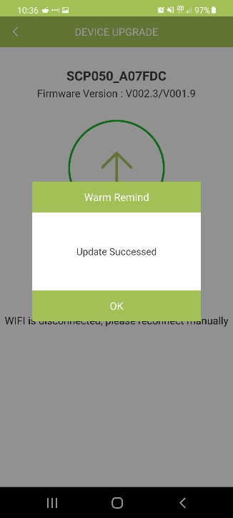
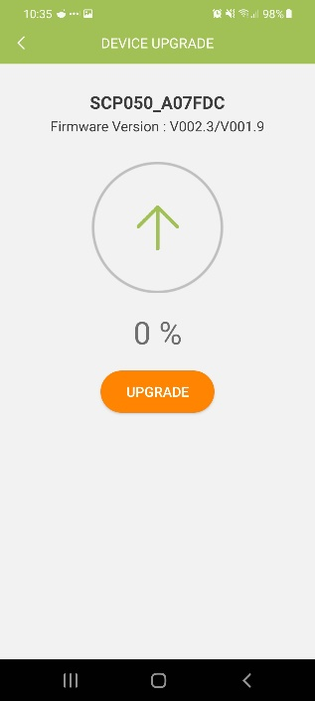
- Press update. Device will show the progress of the update. Please DO NOT close app
or change to a different application, doing so may interrupt update resulting in
damage to controller.

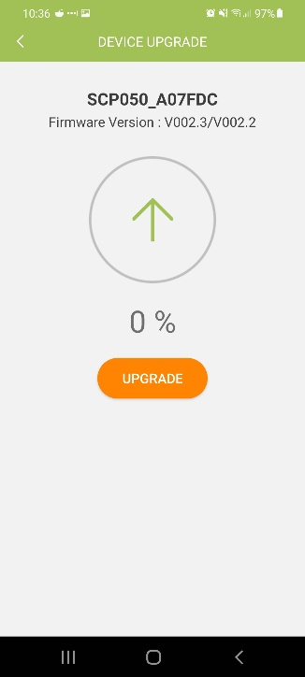
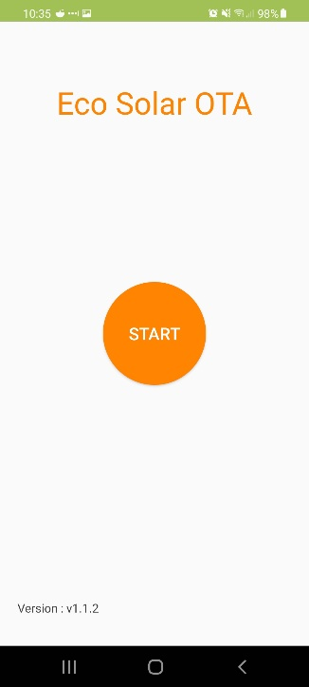
- Once complete, message box will appear informing of the successful update. Select
“ok” and the app will take you back to the home screen in step 3. The solar
controller will restart and Wi-fi connection will be lost. Once the solar controller
power on again, Wi-fi connection will automatically reconnect.

- Once connection has been re-established, press “start”,
here you can see the new firmware has been installed to the
solar controller IE V002.3/V002.2
From here, the solar controller firmware has been updated
successfully.

- Download Eco Solar OTA app from Google play store / IOS App store
- Connect mobile device to ProvistaSolar_xxxxxx Wifi network (password: 12345678)
- Open ECO Solar OTA app
- Click Start
- Confirm Solar Controller Part number (IE SCP030 or SCP050)
- Confirm unit address (will be the same as the WIFI SSID (EG : SCP050_A07FDC)
- Take note of the Firmware Version (EG: V002.3/V001.9)
- Click update, DO NOT close the ECO Solar OTA APP or remove any connections to the solar controller while unit is updating
It is normal for the screen on the solar controller to freeze while the update is progress
The unit will automatically restart on completion of update
- To confirm update was successful, close ECO Solar OTA App and re-open,
- Click start and the Firmware version should have changed (EG: V002.3/V002.4) Please note, the first set of numbers (V002.3) wont change, only the last set.

